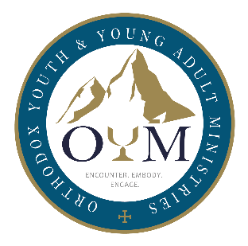 | Orthodox Youth & Young Adult Ministry Awareness Sunday  Sept. 24, 2023  Promotional Blurbs

We invite parishes to help promote OYM Sunday by including one of the following blurbs in their Sunday bulletin, email message, or other communication venues.

Longer version

With approximately 60% of youth leaving the church once they become adults, it’s vital for everyone to work together in helping our young people find joy in Christ and become full participants in the life of the Church. Orthodox Youth & Young Adult Ministries (OYM) was created to help parishes, priests, parents, and other caring adults accomplish this. Through transformative events and ministry resources, OYM helps young people encounter Christ, embody the Church, and engage the world in His name.

The Assembly of Orthodox Bishops has designated September 24, 2023 as Orthodox Youth & Young Adult Ministry Awareness Sunday. We invite everyone to learn about OYM’s ministry, sign up for their newsletter, and consider supporting them by visiting www.TheOYM.org.

Shorter version

Orthodox Youth & Young Adult Ministries (OYM) was created by the Assembly of Orthodox Bishops to help parishes, priests, parents, and other caring adults help young people find joy in the Orthodox faith by encountering Christ, embodying the Church, and engaging the world in His name. September 24, 2023 has been designated as Orthodox Youth & Young Adult Ministry Awareness Sunday. We invite everyone to learn about OYM’s ministry, sign up for their newsletter, and consider supporting them by visiting www.TheOYM.org.

Social media

Individuals can also connect with OYM via the following social media links:

Facebook: www.facebook.com/theoymofficial
Instagram: https://www.instagram.com/theoymofficial

